Bootstrapping is any test or metric that uses random sampling with replacement 1 point

.true

.false

--> true

There are no duplicates in a bootstrap dataset 1 point

.true

.false

--> false

.Amount of say is negative number

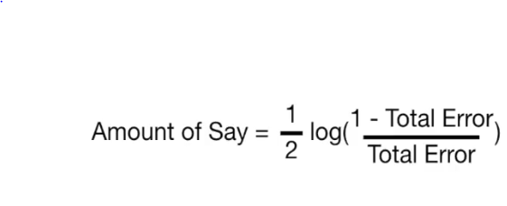1 point

?total error =.6

If total error is equal 0.6 this mean :

.Amount of say is negative number > -1

.Amount of say is negative number < -1

.Amount of say is positive number > 1

.Amount of say is positive number < 1

🡪.Amount of say is negative number > -1

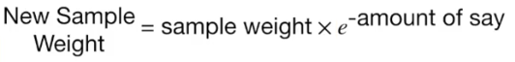1 point

This relation to

. increase sample weight

.decrease sample weight

* decrease sample weight

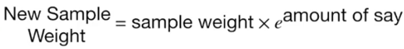1 point

This relation to

. increase sample weight

.decrease sample weight

* decrease sample weight

The Score Test of Random forest between? 2 point

80:85 true

The Score Test of AdaBoost? 3 point

80 : 85 true